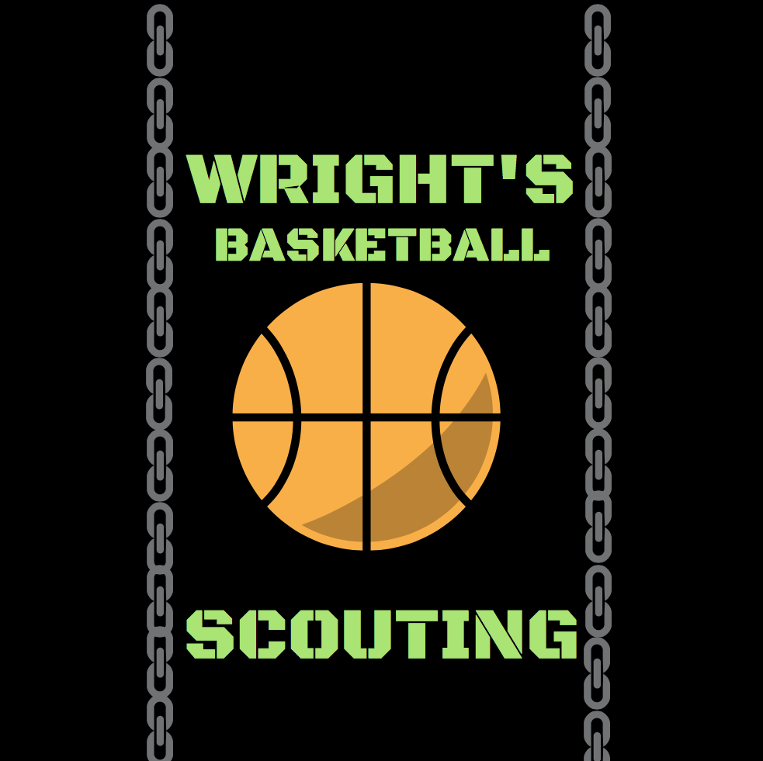

Prospect Report (SAMPLE)
The Twelfth Annual NorCal tip Off Classic. Saturday November 24th. Newark Memorial High School, Newark California. There were eight games played with 16 teams, two teams came from Southern California, the other teams consisted of top Northern California teams. St. Bernard (Playa Del Rey); Santa Margarita (Rancho santa Margarita); Sacred Heart San Francisco); Stuart Hall (San Francisco); James Logan (Union City); Campolindo (Moraga); Dublin; Riordan (San Francisco); Newark Memorial (Newark); St Patrick St Vincent (Vallejo); Moreau Catholic (Hayward); Capital Christian (Sacramento); Bishop O’Dowd (Oakland); Grant (Sacramento); Sheldon (Sacramento); Modesto Christian(Modesto).
The players I have listed are projected to be next level prospects

Name: Je’Lani Clark
Year: 2020
Ht: 6’3
Position: Guard
College Level: Mid-High Major (D1)
High school: Archbishop Riordan (San Francisco)
Coach: Joseph Curtin
AAU Team: Oakland Soldiers EYBL U16
Phone: xxx-xxxx
Email: xxx@xxxx

Demonstrated he can be a dynamic athletic scorer. He consistently beat his defender off the dribble, playing through contact and drawing fouls on his way to the rim to complete the old fashioned 3-point play. He has a quality mid-range jumper, needs to be more efficient on 3-point shooting. He’s a tenacious defender and a guard who can rebound. 10/25 fg and 11/13 ft to finish with 31 points and 6 rebounds.

Name: Bryce Monroe
Year: 2020
Ht: 5’10
Position: Pt guard
College: Low to Mid Major DI
High School: Archbishop Riordan
Coach: Joseph Curtin
AAU: Oakland Soldiers EYBL 16U
Phone: xxx-xxxx
Email: xxx@xxxx

An exciting player to watch, he’s as confident as any point guard you’ll see, has the ability to control the game with his style of play. consistently penetrates the lane and dumps it off to the big man for an easy bucket or can ca somehow kick it out to an open teammate behind the arc for 3.He knocks down ope 3’s consistently and makes most of his mid range shots with a hand in his face. In transition his handles and fearless attacks going to the rim make him a difficult player to contend with.

Name: Elijah Alonso
Year: 2020
Ht: 6’2
Position: Guard
College Level: Juco,DII
High school: Dublin
Coach: Tom Costello
AAU Team: N/A
Phone: xxx-xxxx
Email: xxx@xxxx

He was on fire the first half going 6/6 from the perimeter, converting 8/10 fgs and 5/6 from the 3-point area scored 24 points. This junior got hot in the first half displaying his excellent shooting form and quick release.His shot ranges from a solid mid range all the way out to 3- point land. Probably going to have to work on attacking the rim.

Name: Brett Thompson
Year: 2020
Ht: 5’10
Position: point guard
College Level: Juco DII low DI
High School: James Logan
Coach: Mel Easley
AAU Team: Team Arsenal
Phone: xxx-xxxx
Email: xxx@xxxx

No team has played a tougher schedule than Logan in Nor Cal. Brett continues to play every minute of every game on go. He has the motor, and doesn’t seem to get tired. He’s an exceptional perimeter defender, applies full court man to man pressure, moves well laterally and seldom gets beat off the dribble. A good facilitator, fearless on the attack to the basket, solid pull up and knocks down the open 3-point shot.

Name: Endigo Coleman
Year: 2020
Ht: 6’3
Position: Guard
College Level: Juco, DII
High school: Newark Memorial
Coach: Craig Ashmore
AAU Team: Team Arsenal
Phone: xxx-xxxx
Email: xxx@xxxx

I’ve seen this prospect a couple times in the summer. He works tirelessly on improving his skill set. Right now he’s more of a slasher who finishes well at the rim, a good ball mover and screener. His biggest asset right now is he has a long wingspan, still growing into his body. Defensively he’s going to really excel at the next level, he deflects at least two or three passes a game. While he continues to work on his skill set. He might be labeled a sleeper.

Name: Marcus Bagley
Year: 2020
Ht: 6’8
Position: Guard/Forward
College: Mid to High Major DI
High School: Sheldon
Coach: Joey Rolling
AAU: Phamily
Phone: xxx-xxxx
Email: xxx@xxxx

Marcus made his way to Nor Cal because his brother was drafted by the Sacramento Kings. He becomes the top prospect in Nor Cal because of the skill set a player of his size poses. He moves like a seasoned player under control not forcing the action, always in the flow of the game whether it’s knocking down a long range 3-point shot or using his size off the dribble drive to get to his scoring spot. Maintains solid ball handling skills and has become an excellent passer willing to feed open teammates. Plays the post area in high school, but could be a solid wing player at the next level.

Name: Josh Williams
Year: 2020
Ht: 6’2
Position: Guard
College: Juco, DII, Low DI
Coach: Joey Rollings
AAU: Lakeshow Elite 16’s
Phone: xxx-xxxx
Email: xxx@xxxx

Josh Plays with a lot of emotion, it gets him into trouble sometimes, over time he will have to learn to control them. He’s been a steady performer, his ball handling skills allow him to play either guard position. He shows patience on offense, a good passer and often found teammates open cutting to the basket for the score. He’s a good attack guard from the wings, and can be successful posting up guards because of his strength and jumping ability. On offense he’s a mover and always looking to screen for team mates. He needs to put more work into his mid-range and 3-point shooting.

Name: Xavion Brown
Year: 2020
Ht: 6’2
Position: Guard
College: Low to Mid DI
Coach: Joey Rollings
AAU: Lakeshow Elite 16’s
Phone: xxx-xxxx
Email: xxx@xxxx

This prospect hasn’t defined what type of player he’s going to be at the next level. Most agree he’s a freakish athlete with incredible potential. Right now he’s a combo until he can define his skill set to fit either the one or the two guard position. His ball handling and passing skills are good enough for the one spot, his shooting skills aren’t yet up to par for the two spot, he’s got some work to do. The one thing I know is he’s a prospect that can become a top defender, he deflects a lot of passes with his long arms, he has incredible hops as a defender to go up and get the block. Body language needs to improve along with the rest of his offensive skill set.

Name: Devin Day
Year: 2022
Ht: 6’3
Position: Guard
College: Mid to High Major
High School: Modesto Christian
Coach: Brice Fantazia
AAU: Chuck Hayes Elite U16
Phone: xxx-xxxx
Email: xxx@xxxx

Every now and then a Freshman is ready to play varsity basketball. Devin is one that’s ready. He is already one of the most dangerous spot up shooters in California. Yeah he’s a fresh, and there are some things to work on, but he has three years to build a skill set, he’s already attracting attention from college coaches.

Name: Leonard Turner
Year: 2019
Ht: 6’5
Position: Wing
College: DII, low to mid DI
High School: Moreau Catholic
Coach: Frank Knight
AAU: Splash City
Phone: xxx-xxxx
Email: xxx@xxxx

Leonard started the season off as a focused senor looking like he wants to play DI ball. the lefty has added a strong two dribble drive from the wing. His shooting range is improve since the last time I saw. At 6’5 he has good lateral movement to guard away from the basket.

Name: Glen Byrd
Year: 2019
Ht: 5’11
Position: Pt guard
College: Juco, DII
High School: Moreau Catholic
Coach: Frank Knight
AAU: KBA
Phone: xxx-xxxx
Email: xxx@xxxx

This prospect is playing solid ball in the early season. In two games his shooting shooting has given him the confidence to look for his shot more. He already has strong drives to the rim and a nice pull up game. He’s a strong player that likes to be physical with other guards. can contribute right away at the Juco level.

Name: David Hector
Year: 2019
Ht: 6’3
Position : Guard
College: Juco, DII, Low DI
High School: Moreau Catholic
Coach: Frank Knight
AAU: KBA
Phone: xxx-xxxx
Email: xxx@xxxx

High energy player, plays fast and hard, very difficult to contain in the open court. He attacks hard and can finish with either hand, in the half court his strength allows him to attack from the wing with the two dribble drive. A good rebounding guard, he can also defend both guard positions, he has good quickness and lateral movement. Needs to work on mid-range shot.

Name: Duante DJ Johnson
Year: 2021
Ht: 6’7
Position: Forward
College: Mid DI
High School: Moreau Catholic
Coach: Frank Knight
AAU: Team Arsenal 15U
Phone: xxx-xxxx
Email: xxx@xxxx

DJ might be the most active offensive rebounder in his class. No one has attacked the offensive boards the way this youngster does. He’s bouncy and relentless when it comes to going after rebounds. He kind old school when it comes to blocking shots, he’s got that one hand reaching out trying to swat everything to a team mate instead of trying to send it to the stands. His offensive game needs some polishing up whatever his defined position may be. He gets his hands on a lot of balls but doesn’t always secure it. He’s probably going to get his minutes in high school around the post area, but he’s been working on his spot up shot in the corner from 3-point distance.

Name: Gabriel Hawkins
Year: 2019
Ht: 6’5
Position: Wing/forward
College: DII
High School: James Logan
Coach: Mel Easley
AAU: Team Arsenal
Phone: xxx-xxxx
Email: xxx@xxxx

Gabe is a quiet competitor that gets overlooked because of the guards on this team, but when you look at what he’s actually doing on the court, he’s contributing to the success of his team. At 6’5 and weighing around 230, he doesn’t get pushed around in the post. He’s a rebounder, he’s got a nice shot from the high post area and will knock down 3-point shots. He’s got to get a little quicker! A good DII pick up.

Name: Tsonte Tsartsidze
Year: 2019
Ht: 6’9
Position: Center/forward
College: Low to Mid Major DI
Coach: Brice Fantazia
AAU: Chuck Hayes Elite U17
Phone: xxx-xxxx
Email: xxx@xxxx

16 pts, 14 rebs, and 4 blocks was named mvp in this showcase game. He’s still developing and growing into his body so improvement is on the way. His footwork around the basket was the key to his success around the basket. Can also step outside and shoot at good range including the three on occasion.

Name: Alex Merkvilade
Year:2020
Ht: 6’8
Position: Forward
College: Low to Mid Major DI
High School: Modesto Christian
Coach: Brice Fantazia
AAU: Chuck Hayes Elite U16
Phone: xxx-xxxx
Email: xxx@xxxx

This prospect hasn’t been playing basketball very long. The good news is he’s learned the game at a rapid pace and has become one of the go to guys around the basket for this team. He loves contact in the post, with a soft touch and good footwork, he’s tough to deal with. His range is about 12 to 15. Being new to the game. He will get a lot of attention on the summer circuit. Will be playing U17.

Name: Michael Pearson
Year: 2020
Ht: 5’10
Position: Pt guard
College: DII, Low to Mid Major DI.
High School: Modesto Christian
Coach : Brice Fantazia
AAU: Chuck Hayes U16
Phone: xxx-xxxx
Email: xxx@xxxx

Made a name for himself in the summer. Probably one of the top ranked point guards in NorCal. As always, point guards that play at a high level can handle any kind of ball pressure including traps. He’s a tough competitor who makes the right decisions when the game is on the line. He has a tendency to be the one making the crucial play, whether it’s passing to the post, finding a open wing for three, or just attacking the basket for a crucial and one. He’s that kind of player.

Name: Earv Knox
Year: 2020
Ht: 5’10
Position: Pt guard
College: DII, Low DI.
High School: Modesto Christian
Coach: Brice Fantazia
AAU: The Truth
Phone: xxx-xxxx
Email: xxx@xxxx

Knox just does whatever he can do to help his team win. He’s a pass first point guard, but is capable of scoring on his own . He’s what a solid point guard does he sacrifices for the good of the team. He’s a nice player to have on the floor during times when the game gets a little out of whack, he settles the offense in the half court, he’s a good pick and roll guard. He’s got good foot speed which enables him to be a good on ball defender.

Name: Dathan Satchell
Year: 2019
Ht: 6’3
Position: Guard
College: DII, Low DI
High School: Modesto Christian
Coach: Brice Fantazia
AAU: EBO
Phone: xxx-xxxx
Email: xxx@xxxx

Dathan has the ability to quickly set his feet and have a quick shooting release. He’s a streaky shooter, he might hit three in a row then miss. A good runner off screens, he’ll be a capable handler at the next level, and will be able to create his own shot when he gets all his skills together he will make a solid DII, player.

Name: Carter Mahaney
Year: 2020
Ht: 6’2
Position: Point Guard
College: Low to Mid Major DI
High School: Campolindo
Coach: Steven Dyer
AAU: WCE NorCal 16U
Phone: xxx-xxxx
Email: xxx@xxxx

It was good to see Carter playing point guard against quality competition. He’s often pressured bringing the ball up court because he’s not flashy and defenders think they might be able to force a turnover. Since the summer he’s been playing the point working on clearing everyone out, facing up his defenders and using his arms and body to speed dribble into the front court using the left and right hand. He’s always been a guy with a solid mid range jumper and quality 3-point shooter. I’m looking forward to seeing him in the summer.

Name: David Ahazie
Year: 2019
Ht: 6’3
Position: Wing
College: Juco, DII
High School: Campolindo
Coach: Steven Dyer
AAU: N/A
Phone: xxx-xxxx
Email: xxx@xxxx

David Ahazie is a new comer for me. I didn’t see him during the summer. He’s the leading scorer for his high school team at 16 ppg. David’s more of a scorer in my opinion, he has to rely on his team mates to get him the ball, he’s a good catch and shoot guy with a different kind of release on his shot, and he’s been pretty effective with it from mid-range. He’s been a slasher on occasion with his constant movement to get open. He has a long wingspan and moves well laterally, can be a solid defender at the next level.

Name: Aidan Mahaney
Year: 2022
Position: Guard
College: Mid to High Major DI
High School: Campolindo
Coach: Steven Dyer
AAU: WCE NorCal 15U
Phone: xxx-xxxx
Email: xxx@xxxx

This freshman stepped right into the starting line up on day one, right beside his older brother Carter. I saw him play a couple of times in the summer with WCE, he showed then that he was one of the better freshmen entering high school in NorCal. He’s a confident prospect with a good skill set to compete at a high level, plays both guard positions, brings the ball up without any real problems, has a variety of moves going towards the rim and is a better than average 3-point shooter. Being a Freshman he’s going to be one to watch for the next few years to see if he will raise his game to the level some expect.

Name: Nigel Burris
Year: 2021
Ht: 6’6
Position: Wing/Forward
College: Low to Mid Major DI
High School: Stuart Hall
Coach: Charles Johnson
Phone: xxx-xxxx
Email: xxx@xxxx

A still developing prospect has two years to improve his skill set. The one thing he has proven is that he can play with fouls. He tends to pick up cheap fouls. When he’s on his game he has a thorough understanding of what it takes to be a top prospect with his size and abilities. He’s been working on his outside shot from the wings and the spot up 3-point shot from the corner, he is a decent post player who’s more effective on the block, but I think he’s looking at what position he’ll be playing in college. His shooting form is good and he’s got a nice high post jumper. If he’s going to play the wing he’ll have to start putting the ball on the floor and getting to the basket more.

Name: Will Chavarin
Year: 2019
Ht: 6’3
Position: Combo guard
College: DII
High School: Bishop O’Dowd
Coach: Lou Richie
AAU: Splash City
Phone: xxx-xxxx
Email: xxx@xxxx

The Bishop O’Dowd guard shows his versatility by playing both guard positions, depending who he’s on the floor, he finds ways to be effective, at the point position he’s a good handler who gets others involved with his good passing. He does a good job leading the transition break. He does a good job of scoring off the dribble. He comes off screens and can spot up, he gets exceptional lift on his jump shot. I’m thinking he’s probably better suited playing the 2 guard in college.

Name: Iniko McNeil
Year: 2019
Ht: 5’10
Position: Pt guard
College: Juco, DII
High School: Bishop O’Dowd
Coach: Lou Richie
AAU: Team Arsenal Elite
Phone: xxx-xxxx
Email: xxx@xxxx

Good focus on the court, plays with intensity. A proficient ball handler who can penetrate to score or kick it out to an open teammate. Excellent pick and roll type guard has a nice mid-range. Solid on ball defender with good foot speed and quick hands.

Name: Taj Phillips
Year: 2021
Ht: 5’8
Position: Pt guard
College: Juco, DII
High School: Bishop O’Dowd
Coach: Lou Richie
AAU: LakeShow 16U
Phone: xxx-xxxx
Email: xxx@xxxx

Taj shows toughness being only 5’8. It’s very difficult to trap and take the ball away from him, most think because of his size they can be overly aggressive and physical with him. That’s not the case he handles himself well. He’s a pass first point guard with good speed and handles, he pushes the ball and makes long hard passes in the open court and he does a good job of setting the offense in half court. His mid-range jumper and 3-point shooting can use some improvement but overall solid. he needs to grow a bit more.

Name: Monty Bowser
Year: 2020
Ht: 6’5
Position: Wing
College: DII, Low DI
Coach: Lou Richie
AAU: N/A
Phone: xxx-xxxx
Email: xxx@xxxx

I hadn’t seen much of Monty since the summer, but he displayed a surprising ability to knock down open 3-point shots. He’s a confident shooter with good spot up form in the corner and wing areas, he can score deep and accurately off the catch. He’s slender and fluid and seems to have good instincts, does need to get stronger though.

Name: Marsalis Roberson
Year: 2021
Ht: 6’4
Position: Wing/forward
College: Low DI
High School: Bishop O”Dowd
Coach: Lou Richie
AAU: Soldiers 15U
Phone: xxx-xxxx
Email: xxx@xxxx

Marsalis just makes plays he really doesn’t have a defined position, but he just needs to be on the floor. He showed me his skill set will expand and improve, his ability to put the ball on the floor with two dribble and finish were impressive, his mid-range game and 3-point shooting will improve when he’s out on the summer circuit and plays on the perimeter a bit more. he runs hard to get out and fill the lanes and or get back on the defensive end.

Name: A.J. McGee
Year: 2020
Ht: 6’0
Position: Point guard
College: DII, Low DI
High School: Grant
Coach: P. Deonard Wilson
AAU: YBA
Phone: xxx-xxxx
Email: xxx@xxxx

AJ is a dribbler he has total control of the offense, the ball is in his control. He’s a good pick and roll type guard who loves to force his way to the rim He tends to over penetrate at times but still is very effective, leads the team in transition and very often finds the right player. He has a smooth mid-range jumper.

Name: Oscar Chang
Year: 2020
Ht: 6’8
Position: Forward
College: Juco, DII
High School: Sacred Heart Cathedral
Coach: Sean MacKay
AAU: SF Rebels
Phone: xxx-xxxx
Email: xxx@xxxx

This junior prospect has made some improvement since the summer. Oscar has put on some muscle, his condition is improved and his footwork is improved, with that kind of off season work his numbers have improved. This game he showed some of the skills needed for a player his size, he was a forcefully rebounding and getting put backs to finish. In the post area he demonstrated the footwork needed to finish shots in the post area, he has to continue to strengthen his body and develop a mid-range game around the top of the key. A good DII prospect.

Name: Caden Flowers
Year: 2021
Ht: 5’10
Position: Pt guard
College: DII, Low to Mid Major DI
High School: Capital Christian
Coach: McCall Wollman
AAU: Team Lillard 15U
Phone: xxx-xxxx
Email: xxx@xxxx

Caden does an excellent job as the primary ball handler for this team, high I.Q. player always looking to capitalize on an opponent mistake. He’s locked in from the beginning, shows leadership always communicating to teammates. Knows when to push in transition and when to set up and run clock. A pass first point guard who has very good vision on the penetration. This 2021 prospect will develop his pull up and mid-range shooting.

Name: Cedric Reed
Year: 2019
Ht: 5’11
Position: Pt guard
College: Juco, DII
High School: Sacred Heart Cathedral
Coach: Sean MacKay
AAU: Road Runners
Phone: xxx-xxxx
Email: xxx@xxxx

Reed has been a steady performer for this team for a while now. a speedy athlete with good handles quick feet and attacks the rim hard and finishes with either hand. A tough-minded leader for this team. His pull up jumper is adequate, his 3-point shooting can improve and he needs to make more of the shots he takes. very quick defensively if he focused more on that side of the ball.

Name: Ray-John Jackson
Year: 2020
Ht: 6’0
Position: Guard
College: DI
High School: Sacred Heart Cathedral
Coach : Sean MacKay
AAU: SF Rebels 15U
Phone: xxx-xxxx
Email: xxx@xxxx

I first saw Ray-John play in the summer SF Rebels 15U. I remember thinking to myself this kid is pretty good, he can score anytime he wants to, but he’s a team player and he lets the game come to him. He showed the potential to be a good floor leader directing team mates. Knowing when to set up or attack. He has the ability to score in several ways. I saw a hard attack to the basket, I saw a nice floater, a solid pull up jumper. This young prospect has to be one of the better 2022’s in NorCal.

Name: Darrion Williams
Year: 2022
Ht: 6’4
Position: wing/forward
College: Low to Mid Major DI
High School: Capital Christian
Coach: McCall Wollman
AAU: Team Lillard 15U
Phone: xxx-xxxx
Email: xxx@xxxx

I saw this prospect in the summer with his AAU team, he has proven to be a player that is adjusting well as the season progresses. At 6’4 he plays the post area for this team. He’s held up well against the older stronger more experienced post players that he goes up against, with that being said he continues to work his outside game, he’s become pretty efficient on his mid-range shooting and his two-dribble drive to the basket. Like any freshman he’s going to improve his skill set over time.

Name: Dishon Jackson
Year: 2021
Ht: 6’10
Position: Forward/Center
College: Mid to Major DI
High School: St. Pats. St. Vincent
Coach: Derek Walker
AAU: West Coast Elite 16U
Phone: xxx-xxxx
Email: xxx@xxxx

Dishon is the top ranked 2021 player at his position in NorCal and ranked in the top 100 in his 2021 class in the state of California. Being 6’10 in high school he can dominate a game rebounding averaging a double double is the norm for this prospect. He’s quite comfortable spotting up in the corner for a 3-point shot. Most of his game right now is built around him playing the post area where can score over most of his opponents. He needs to build more muscle.

